Chapter 11, Solution 16.

For the circuit in Fig. 11.47, find the maximum power that can be delivered to the load Z_{L}.

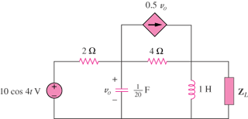

Figure 11.47
For Prob. 11.16.

Solution
We find the Thevenin equivalent at the terminals of Z_{L}. To find V_{Thev}, we use the circuit shown below.
0.5V_{o}

2 V₁ 4 V₂

+
+ +
10<0º V_{o} -j5 j4 V_{Thev}
- -
-

At node 1,

(1)

At node 2,

(2)

Solving (1) and (2) leads to

To obtain R_{eq}, consider the circuit shown below. We replace Z_{L} by a 1-A current source.

0.5V₁
1A

2 V₁ 4 V₂

-j5 j4

At node 1,

(3)
At node 2,

(4)
Solving (1) and (2) gives
and Z_{L} = 3.837∠–60.12° Ω

5.787 W

